PowerBi Viusalization:

**Sales by Product Category:**

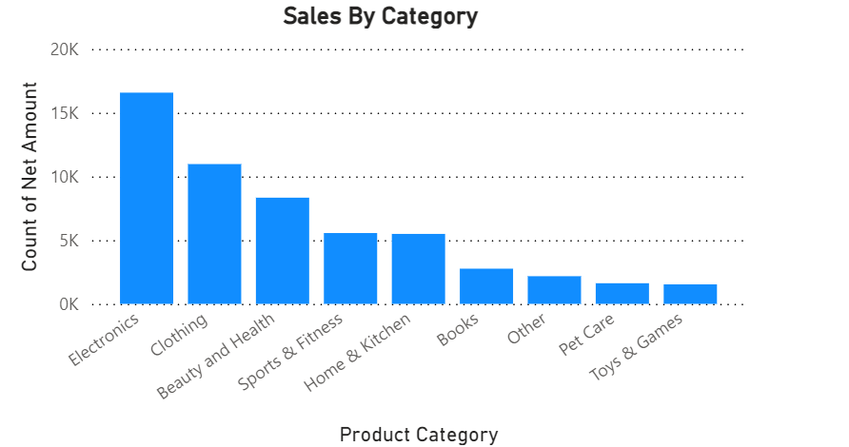

**Gender distribution across product category:**

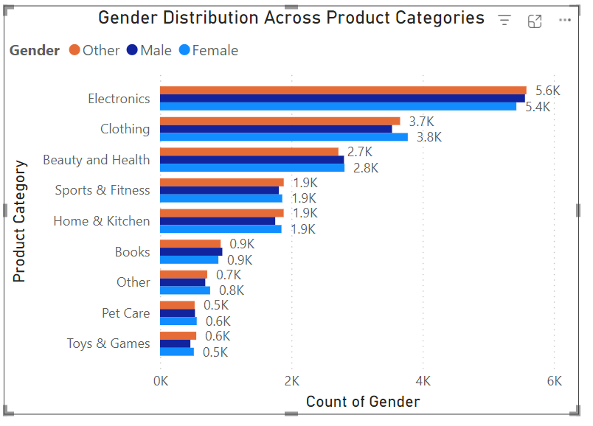

**Sales Trend Over Time:**

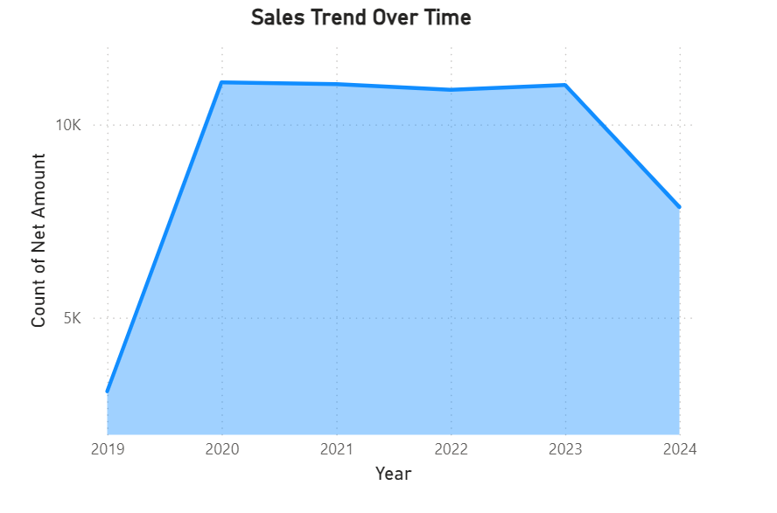

**Customer Demographics Analysis (by gender and net amount):**

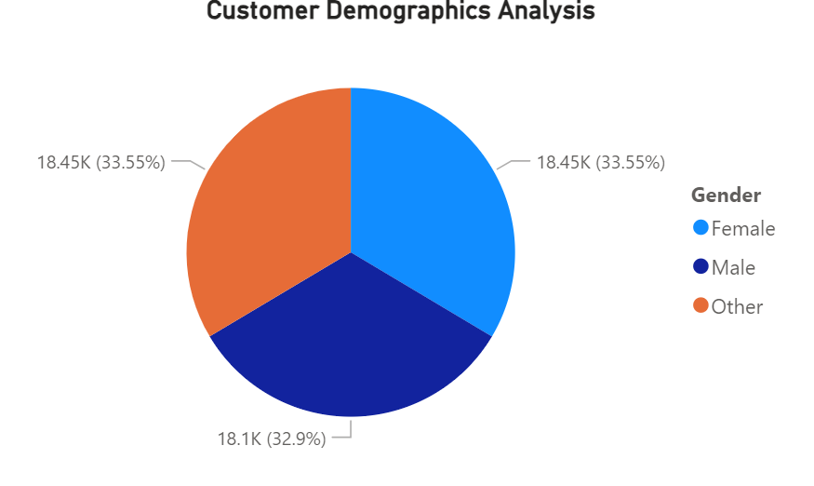

**Customer Demographics Analysis (by age-group and gross amount):**

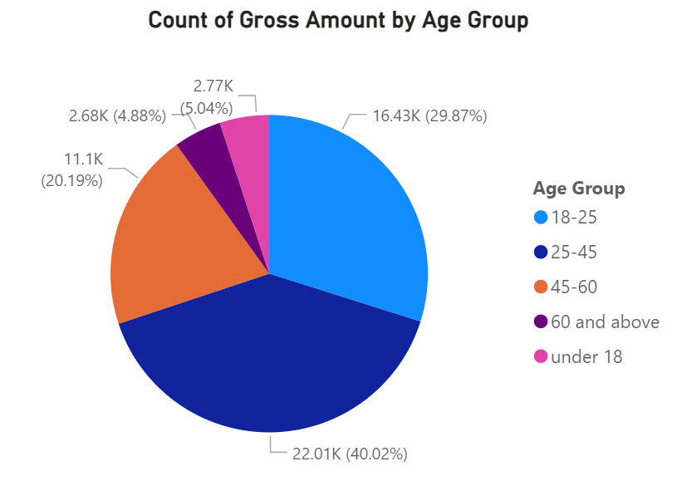

**Location-Based Sales:**

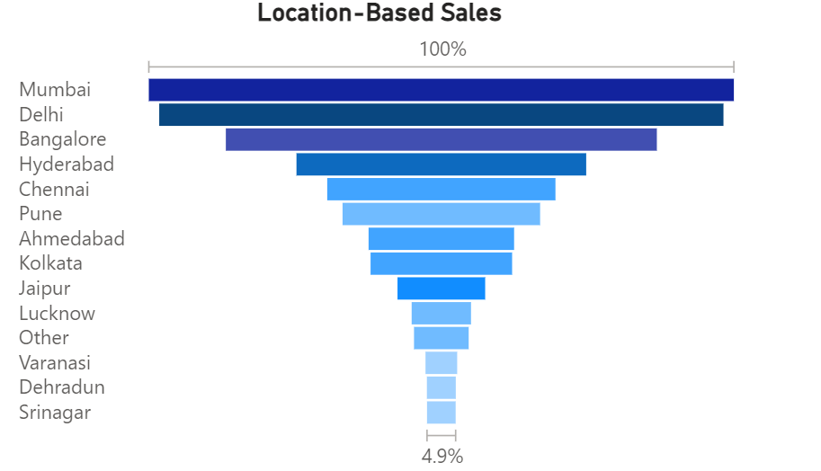

**Discount Impact on Revenue:**

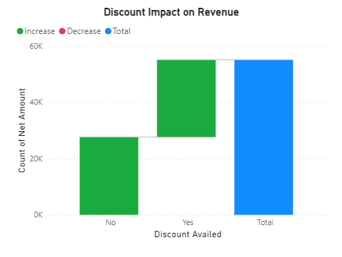

**Top Discounts Used:**

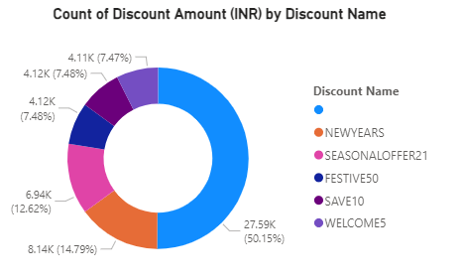

**Payment Method Analysis:**

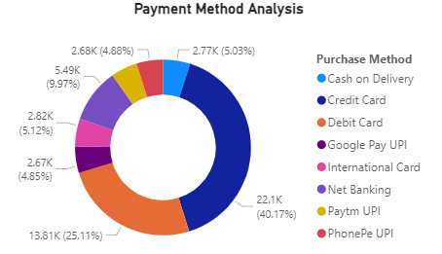

**Average Spending by Age Group:**

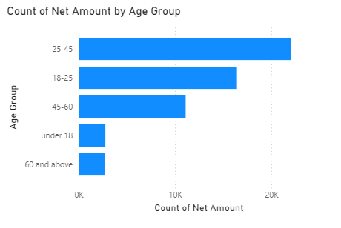

**Gross vs. Net Amount Analysis:**

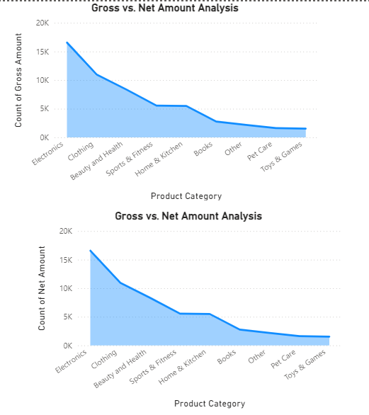

**Gender-Based Discount Usage:**

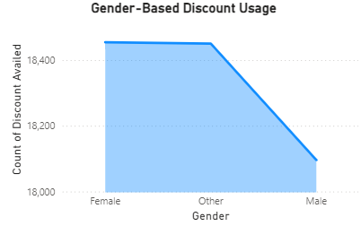

**Matrix Representation:**

